Reporting No:3 Week No:3 From :27/05/2024 To :31/05/2024 College ID: 22IT116

Project Title:

**WEEKLY REPORT**

**Work done in last week ( Attach supporting Documents):**

1. 27/05/2024 Monday

* 9.30am to 11.30 am: Create a top 5 Netflix series in 2024 website and use basic concepts

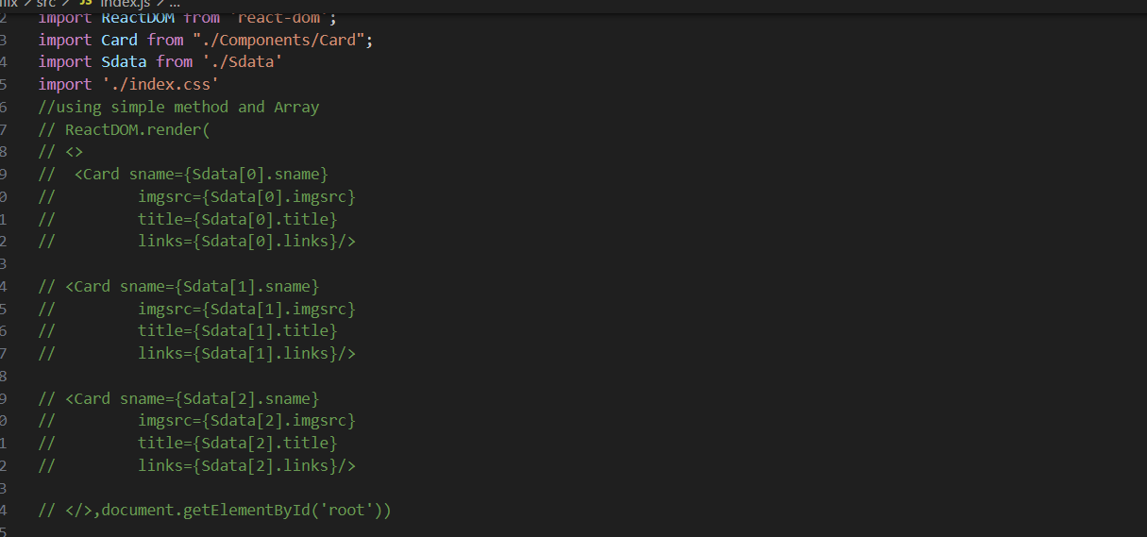

* 12.00pm to 2.30 pm: Replace simple method of Array with Mapping and add Movie and Solve error of image component

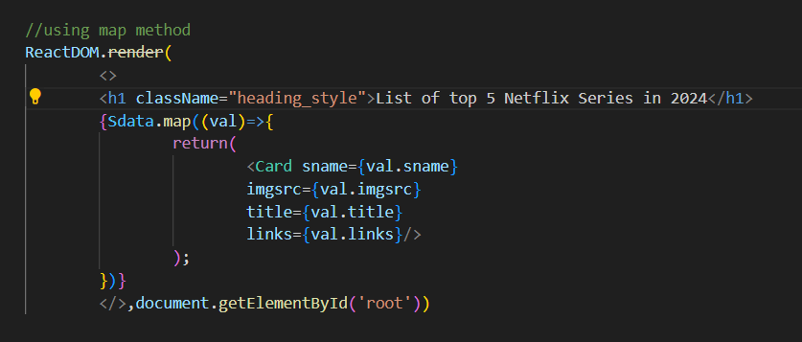

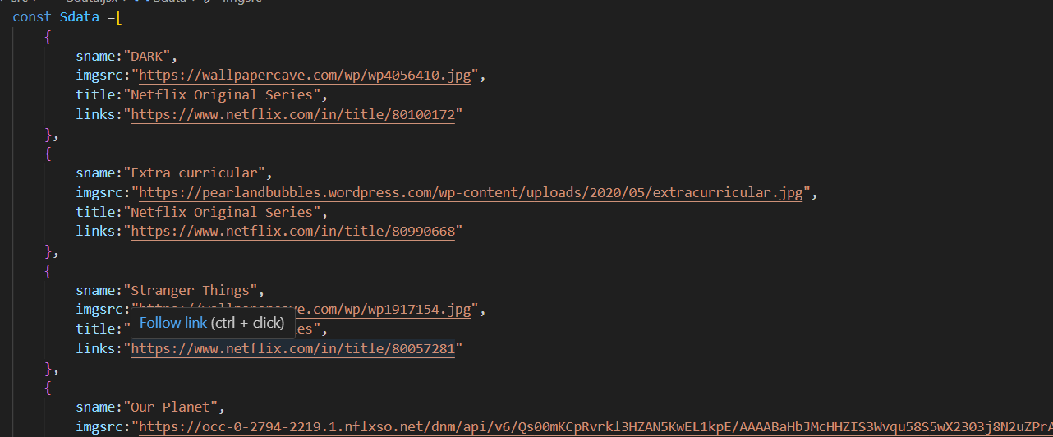

* 3.00 pm to 5.00 pm: Add CSS styling

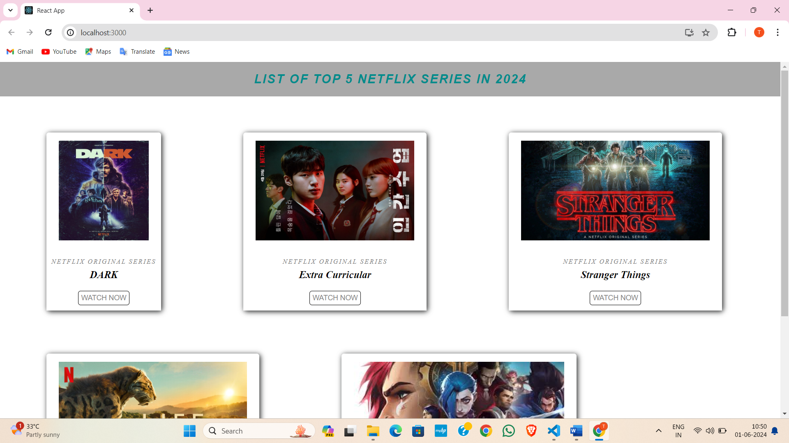

1. 28/05/2024 Tuesday

* 9.30am to 11.30 am: Create a Calculator

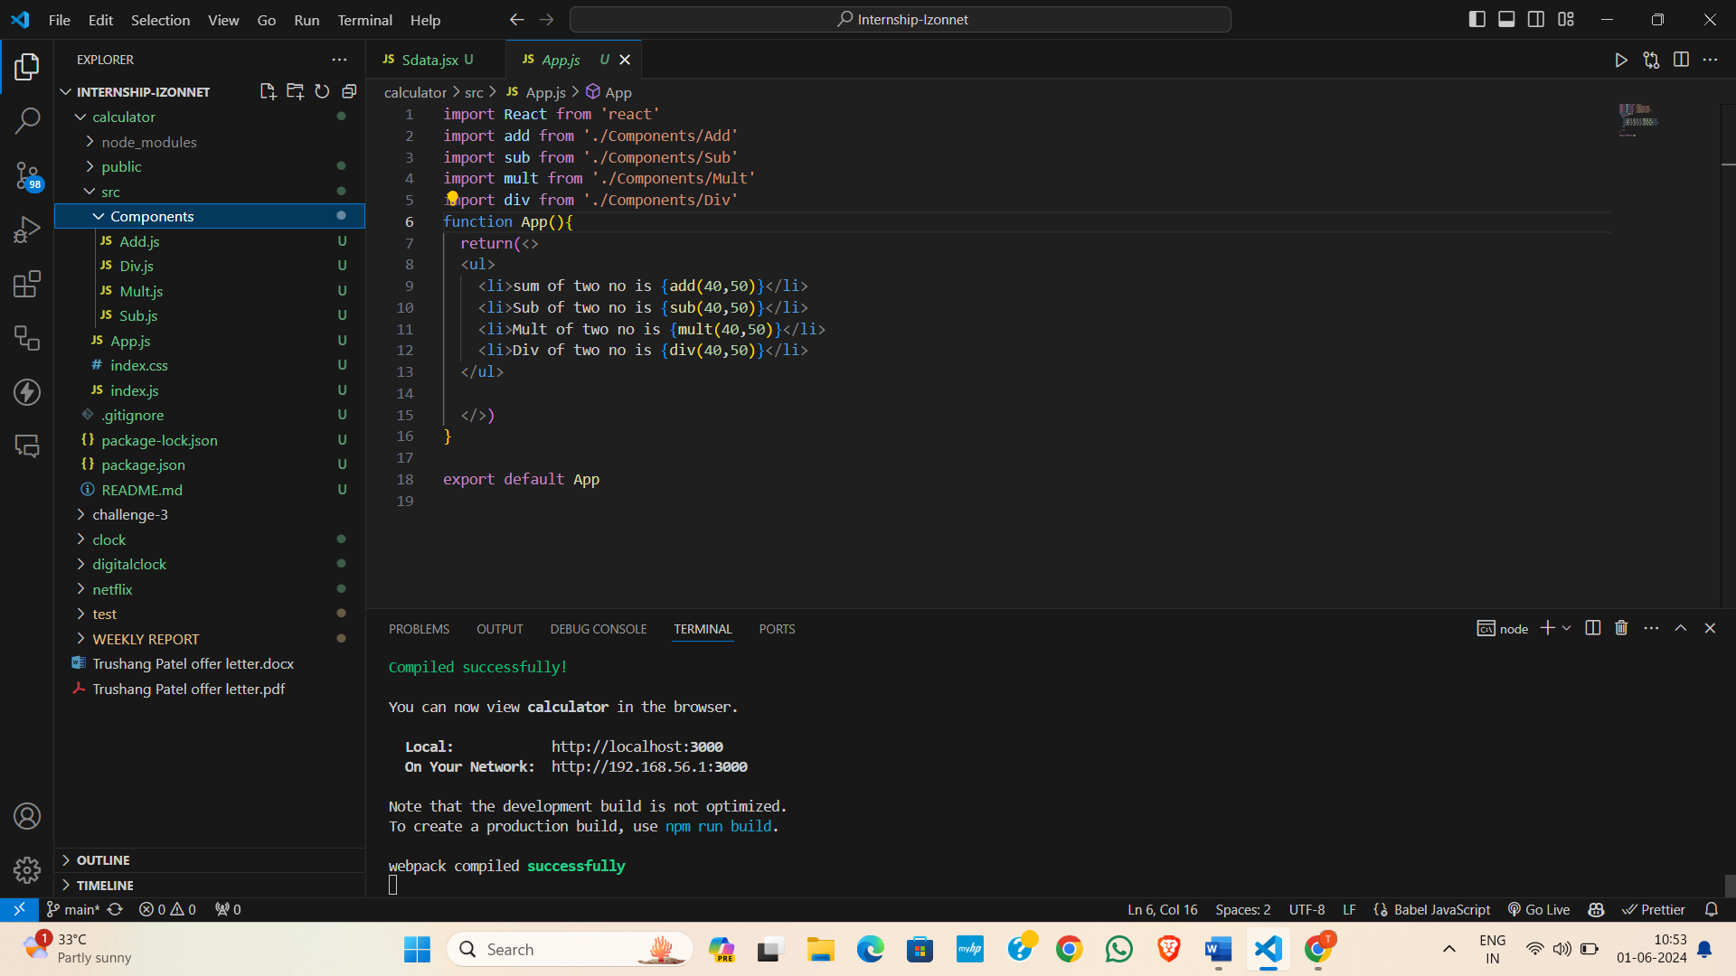

* 12.00pm to 2.30 pm: To learn about Context API

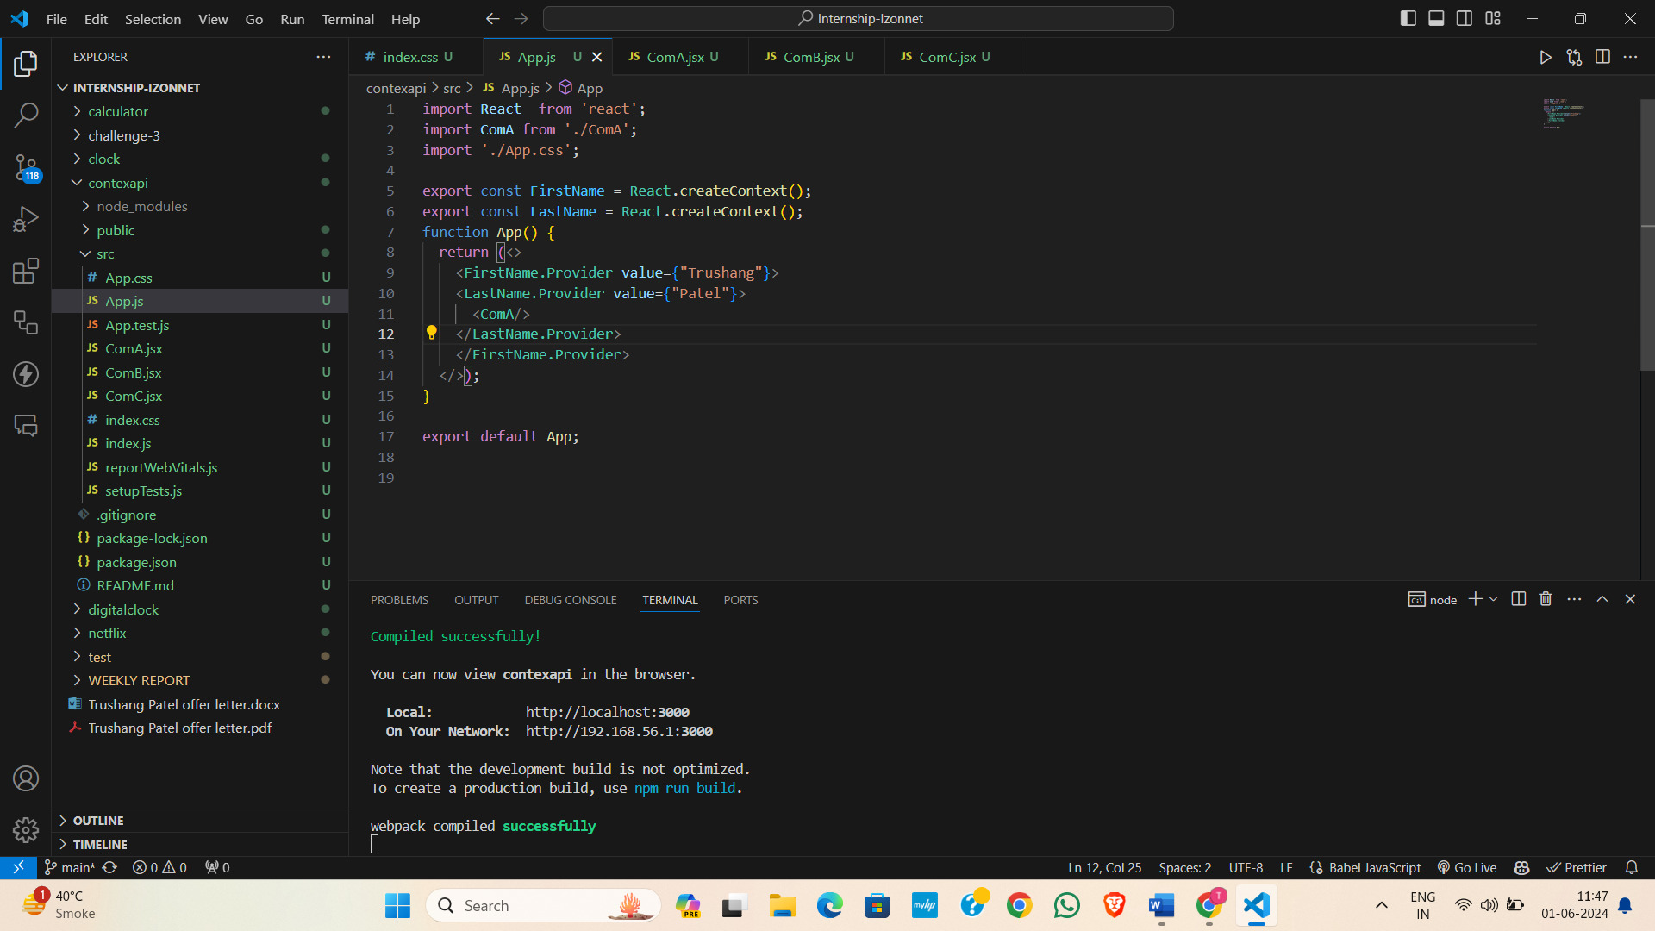

* 3.00 pm to 5.00 pm: Introduction to Express JS and how to install express js

1. 29/05/2024 Wednesday

* 9.30 am to 11.30 am: Express JS routing and how to send HTML and JSON data as a Response

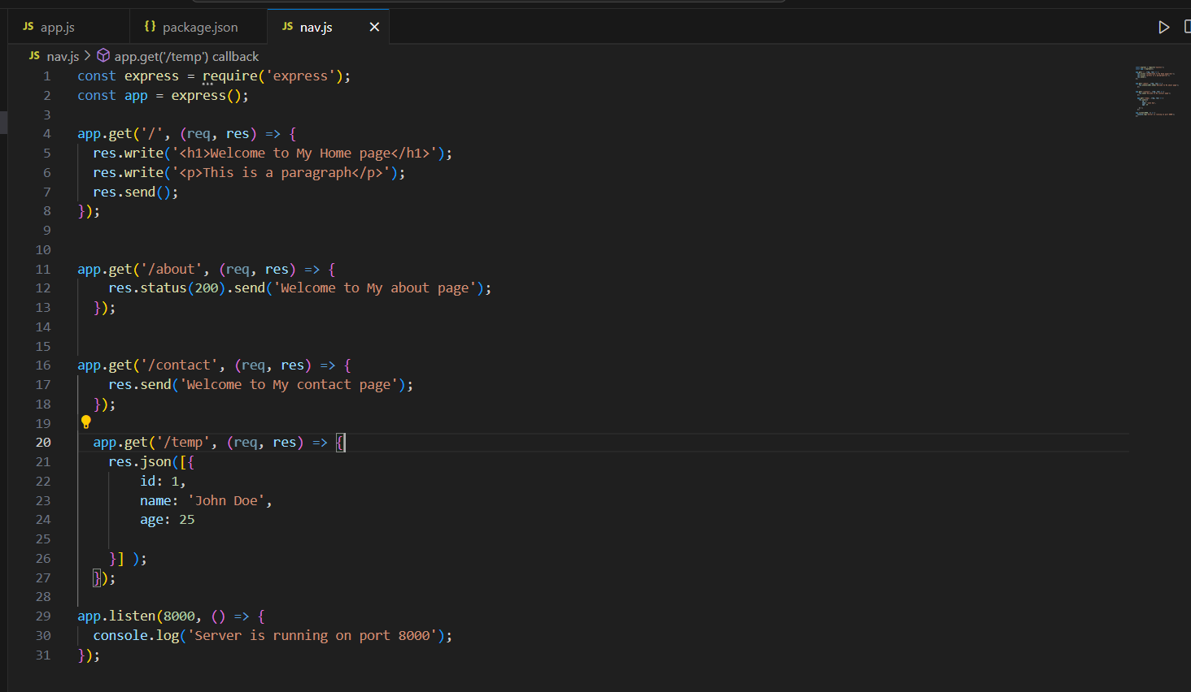

* 12.00pm to 2.30 pm: Serve HTML CSS & JS Files in Express JS | Middleware in Express JS

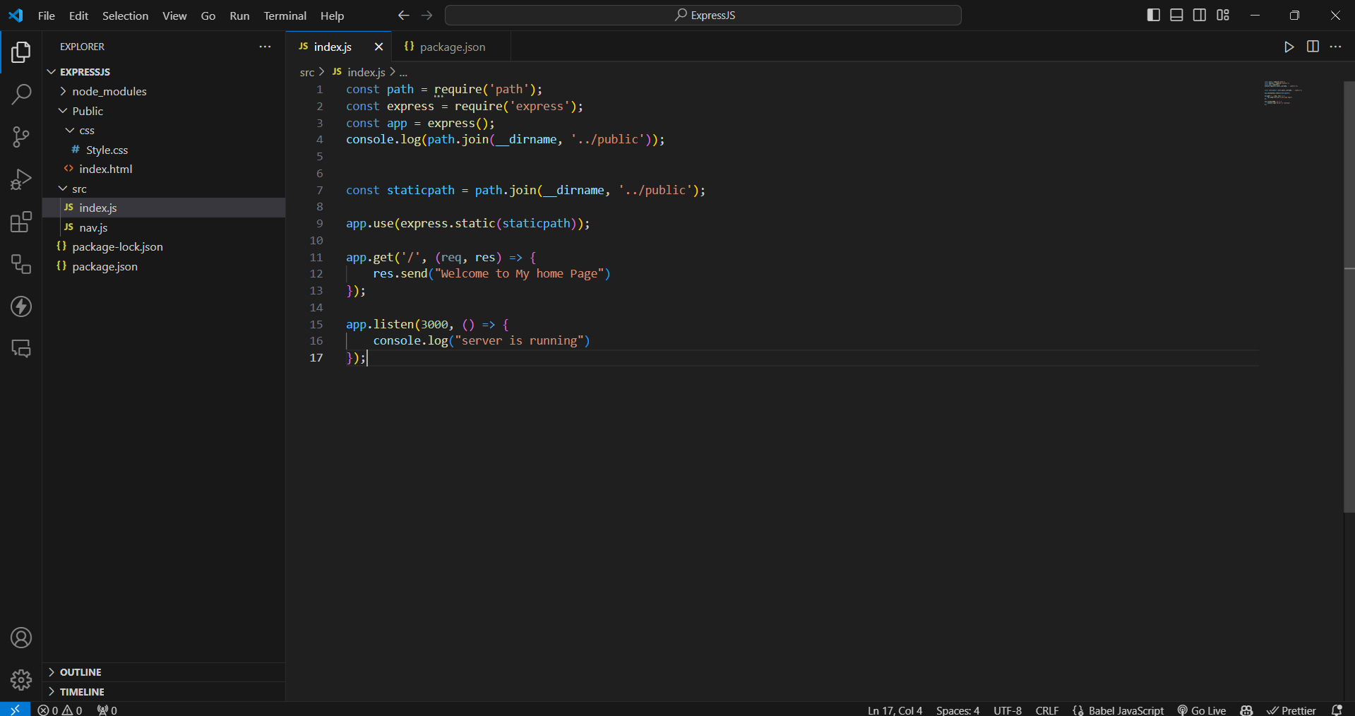

* 3.00 pm to 5.00 pm: Template Engine (Pug, hbs, EJS)

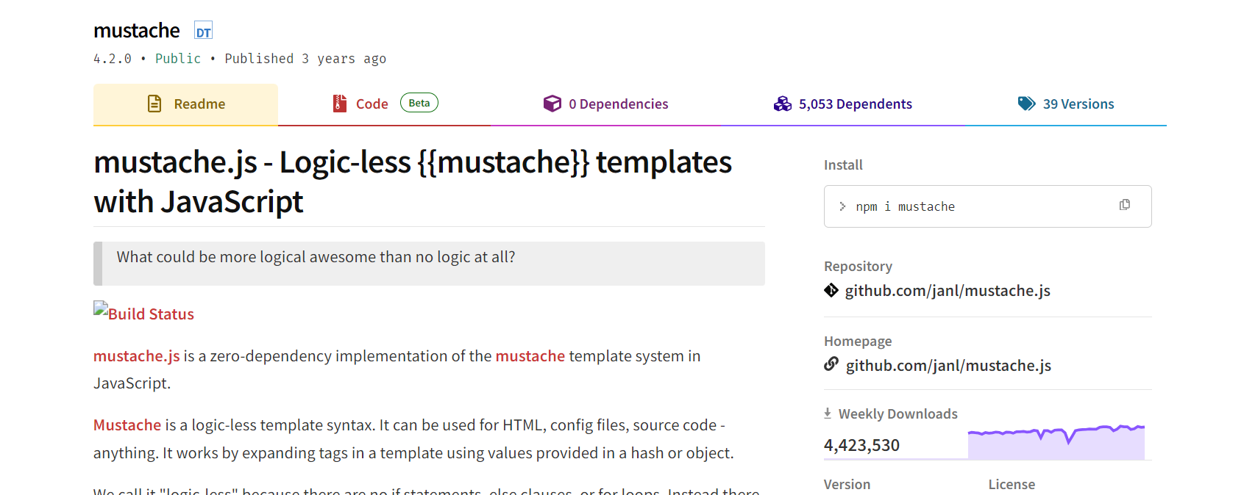

1. 30/05/2024 Thursday

* 9.30 am to 11.30 am: Customizing the Views Directory in Express JS and Using Partials
* 12.00pm to 2.30 pm:
* 3.00pm to 5.00 pm:

1. 31/05/2024 Friday

* 9.30 am to 11.30 am:
* 12.00pm to 2.30 pm:
* 3.00pm to 5.00 pm:

**Plans for next week:**

1. To learn backend part for our website

**References:**

1. YouTube Channel: [Thapa Technical](https://www.youtube.com/@ThapaTechnical)
2. React Documentation

**Signature of External Guide Signature of Internal Guide**

Student Id: 22IT116

Student Name: TRUSHANGKUMAR SUMANBHAI PATEL